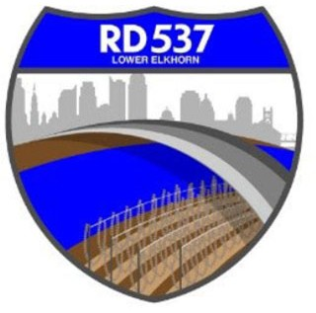
NOTICE OF MEETING AND AGENDA RECLAMATION DISTRICT NO. 537

The Board of Trustees of Reclamation District No. 537 has called a special board meeting to be held at 9:00 a.m. on Friday, June 28, 2024. This meeting is open to the public. Members of the public may attend this meeting in person at 1450 Harbor Blvd. Ste B West Sacramento, CA 95691 or participate remotely, using the following information:
- Online, via Microsoft Teams at https://bit.ly/45Gi7Br
- By phone, at 1-916-538-7032; Conference ID: 718037408

During this period of modified Brown Act requirements, RD 537 will use best efforts to swiftly resolve requests for reasonable modifications or accommodations with individuals with disabilities, consistent with the Americans with Disabilities Act, and resolving any doubt whatsoever in favor of accessibility. If you need a disability related modification or accommodation to participate in this meeting, then please call Billy Mattos at (916) 531-1199 or elkhornrd@gmail.com. Requests must be made as early as possible, and at least one full business day before the start of the meeting.

AGENDA
Call to Order
- Meeting attendance/introductions
- Approval of agenda

Public Comment on Non-Agenda Items District

Business/Action Items
- District budget
  - Consideration of 2024-2025 Assessment rate
  - Approval of 2024-2025 Budget
- Corp Yard
  - Bid Building Contract 2
  - Subconsultant Budget Amendments
- Engineers’ Report and Updates (MBK):
  - FMAP Authorizing Resolution
- Attorneys’ Report

Informational Items
- Additional Informational Items/Trustee Comments
- Adjourn

