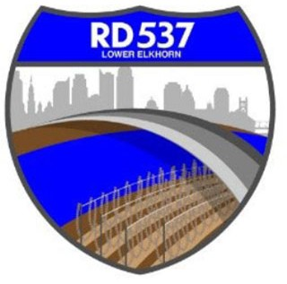NOTICE OF MEETING AND AGENDA RECLAMATION DISTRICT NO. 537

The Board of Trustees of Reclamation District No. 537 has called a special board meeting to be held at **3:30 p.m.** on **Wednesday, February 21, 2024**. This meeting is open to the public. Members of the public may attend this meeting in person at 1450 Harbor Blvd., Suite B; West Sacramento, CA 95691 or participate remotely, using the following information:

* Online, via Microsoft Teams at https://bit.ly/3SIQ0eP
* By phone, at 1-916-538-7032; Conference ID: 735039875#

During this period of modified Brown Act requirements, RD 537 will use best efforts to swiftly resolve requests for reasonable modifications or accommodations with individuals with disabilities, consistent with the Americans with Disabilities Act, and resolving any doubt whatsoever in favor of accessibility. If you need a disability related modification or accommodation to participate in this meeting, then please call Billy Mattos at (916) 531-1199 or [elkhornrd@gmail.com.](mailto:elkhornrd@gmail.com) Requests must be made as early as possible, and at least one full business day before the start of the meeting.

# AGENDA

**Call to Order**

1. Meeting attendance/introductions
2. Approval of agenda

# Business/Action Items

# Consideration to accept a Class B Contractor’s license for the Corp Yard specifications

# Informational Items

1. Additional Informational Items/Trustee Comments
2. Adjourn